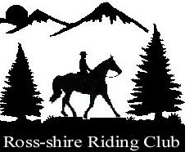 **ROSS-SHIRE RIDING CLUB TRAINING**

TO BE HELD AT NORTH GLASTULLICH FARM, TAIN

with the kind permission of Mrs Lesley Hooper

**TUESDAY EVENINGS**

27TH MAY – enter by 23rd May

17TH JUNE – enter by 13th June

29TH JULY – enter by 25th July

INSTRUCTOR – KAREN MOWAT

SESSIONS AT 6 PM AND 7 PM (Please indicate which is best for you)

FEES – MEMBERS £16, NON MEMBERS £20

ENTRIES ON EQUO

OTHER POINTS

Hats must be of current standards and worn at all times when mounted.

Body protectors must be of current standard.

Children are the responsibility of their parent or guardian at all times.

Dogs should be on a lead.

Please take your litter home with you.